**FORMAN CHRISTIAN COLLEGE (A CHARTERED UNIVERSITY)**



**Technology Management**

**SECTION A**

**Team Members:**

**Hadi Hassan (Project Manager)**

**231469272**

**Shaheer-Ur-Rehman**

**231451798**

**Afnan Ahmed**

**231485855**

**Sheraz Khalid**

**21-10944**

Table of Contents

Introduction 4

JIRA: 4

Jira Usage: 4

Projects 4

Project 2 5

Issue 1: We need a new laptop equipped with ddr5 RAM 16GB 5

Issue 2: Please check the hardware error of CPU 6

Issue 3: IT Operations team, please check for the router issues and internet stability 7

WorkFlow 8

ITSM Project 10

Issue 1: Please update the RAM allocation on the AWS Cloud for our team 10

Issue 2: Please check the hardware error of CPU 11

Issue 3: Our team needs to buy the new license for Talend data service 12

ITSM sample space 13

Request 1: Update Windows 10 to Windows 11 13

Request 2: Need username and Password customer cloud computer to install antivirus. 13

# Introduction

## JIRA:

Jira is a project Management Tool owned by Atlassian for planning, tracking and supporting software and projects. It’s a popular tool used worldwide in IT world and other industries as well.

## Jira Usage:

Jira used for Requirement Management, Task Management, Bug Tracking System, Streamlining, Workflows, Estimations, Reporting, Project Analytics ,Logging and Customization, Email Notifications, Release Planning, Backlog Tracking, Product Road Map Visualization and many more.

# Projects

In this assignment we assigned to work on Jira Service Management and Jira Software and demonstrate how Jira work first I choose the Jira software to make the project and show how to make projects, issue and make sprint and complete. First when you create project it provide templates which you want to work in this project we select the Scrum.

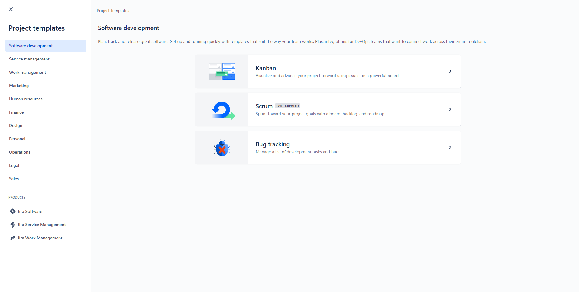

After Creating Project you show like this kind of screen where you easily track your projects. On the left side of the screen you have Planning tabs which contains Roadmap Backlog and Board. In Backlog there all issue you are created.

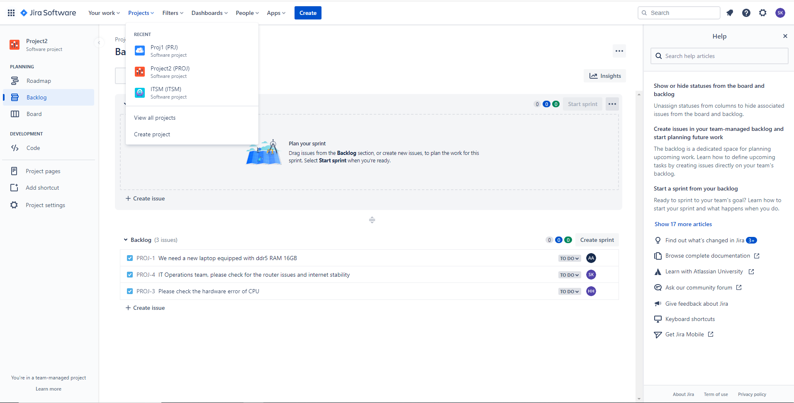

In this I demonstrate the “ITSM Project” and “Project2”

## Project 2

### Issue 1: We need a new laptop equipped with ddr5 RAM 16GB

Task: We need a new laptop equipped with ddr5 RAM 16GB

Assignee: Afnan Ahmad

Reporter: Shaheer-Ur-Rehman

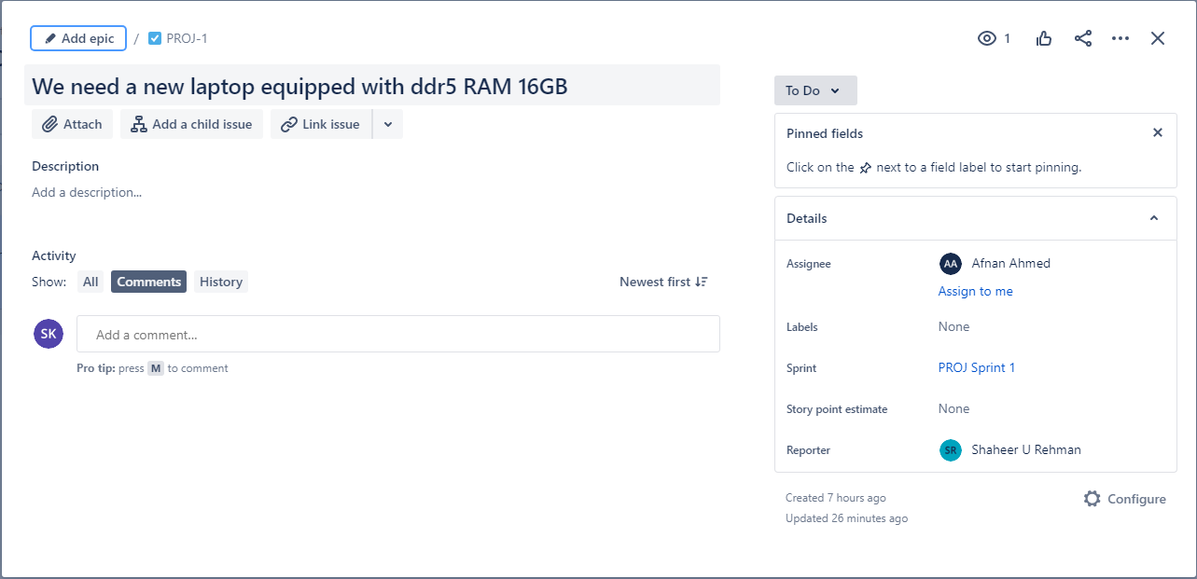

### Issue 2: Please check the hardware error of CPU

Task: Please check the hardware error of CPU

Assignee: Afnan Ahmad

Reporter: Shaheer-Ur-Rehman

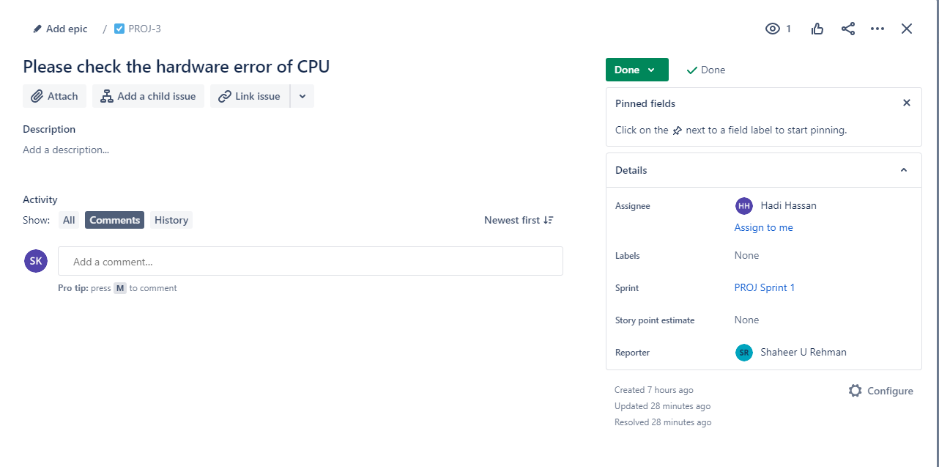

### Issue 3: IT Operations team, please check for the router issues and internet stability

Task: IT Operations team, please check for the router issues and internet stability

Assignee: Sheraz Khalid

Reporter: Shaheer-Ur-Rehman

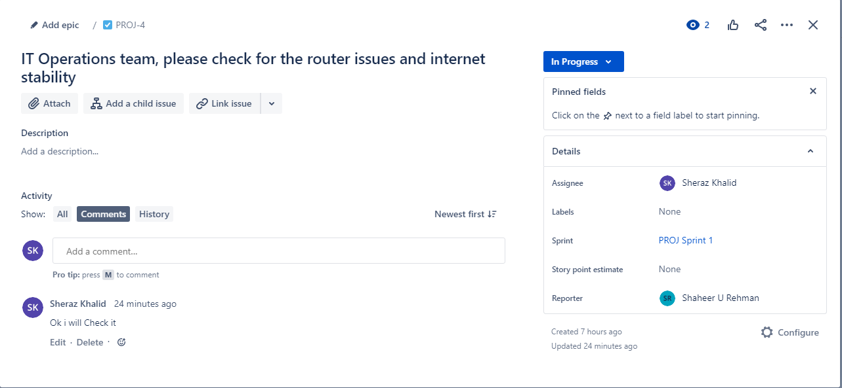

In the above screenshots you see three issue is created and assign to different team members.

### WorkFlow

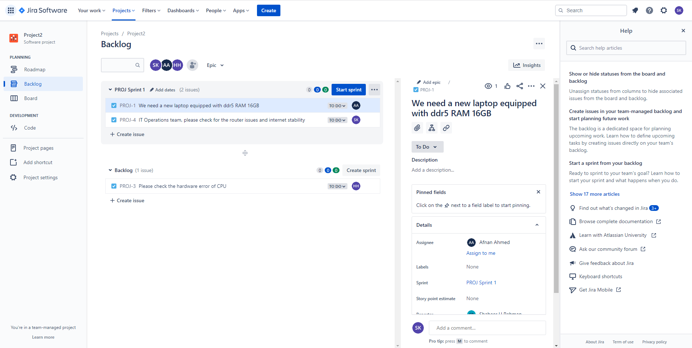

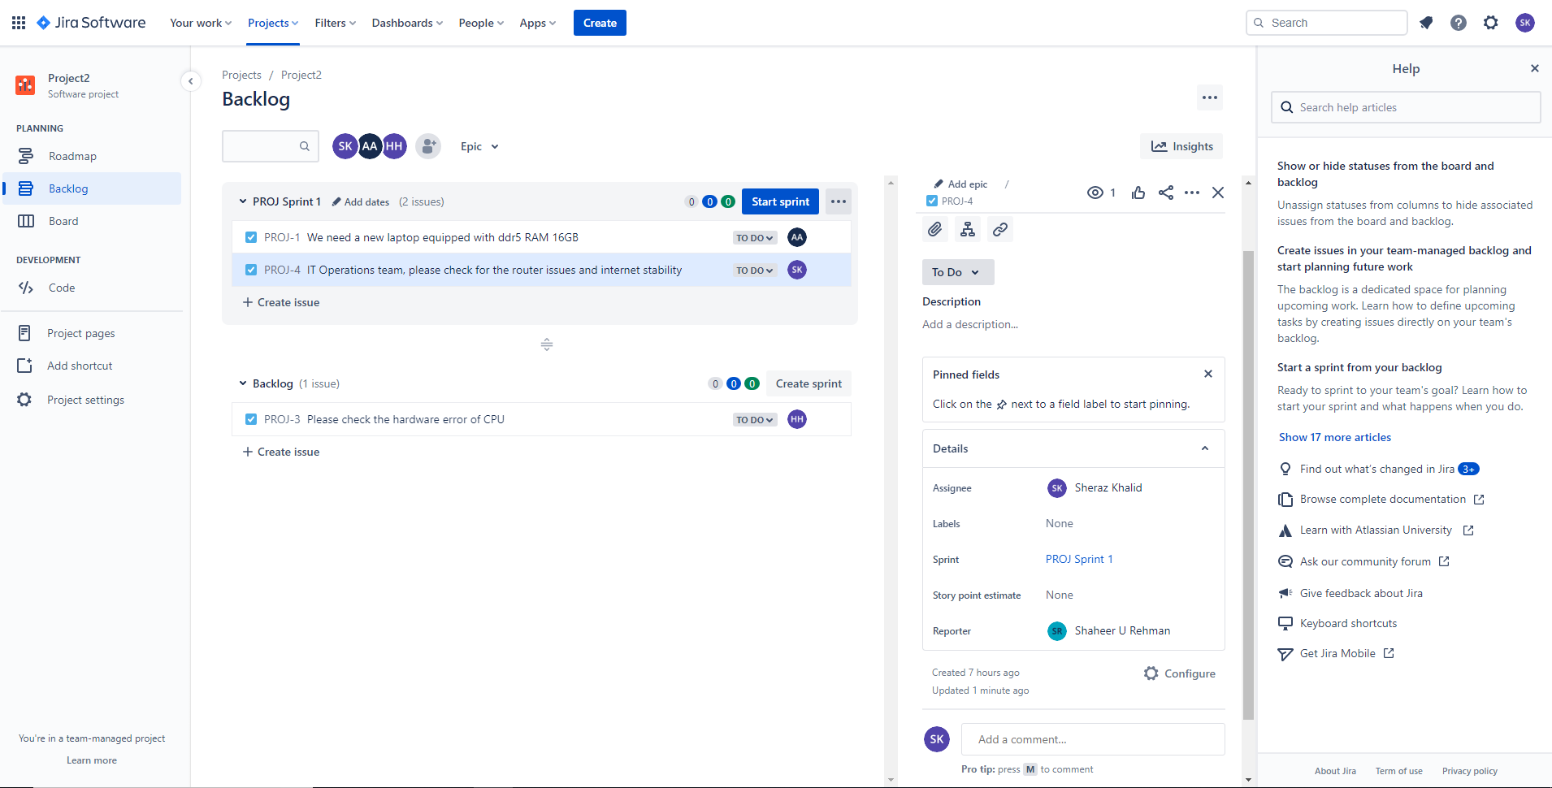

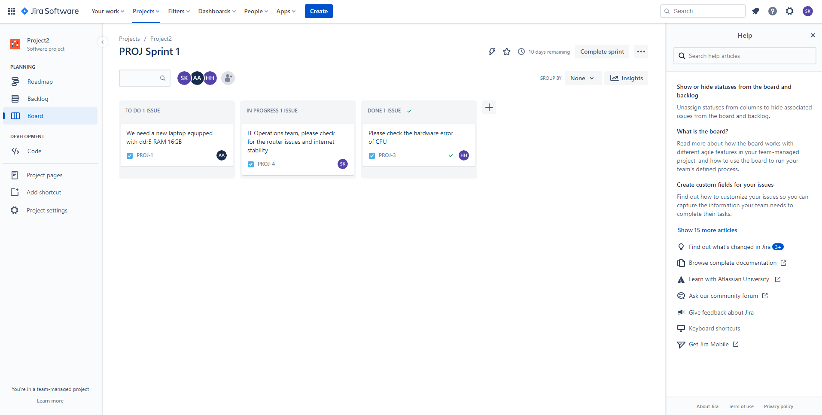

In the screen shot you see that we have three task created. After created we put task in sprint in which we want to work. In this first task is to equipped 16 GB ddr3 ram in laptop who is assigned Affan Ahmad and other task is check the stability of router which is assigned to Sheraz Khalid. In the Board selection easily track the task in which stage. We also customize our board according to requirement. The completed task in under tab.

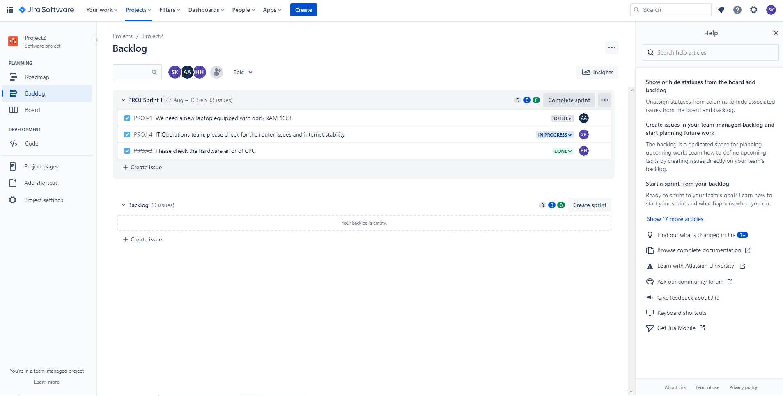

In the Backlog tab you can see which process in which state as you shown in screen shot the first task in done state second one in progress state and the last one in done state.

## ITSM Project

### Issue 1: Please update the RAM allocation on the AWS Cloud for our team

Task: Please update the RAM allocation on the AWS Cloud for our team

Assignee: Shaheer U Rehman

Reporter: Hadi Hassan



### Issue 2: Please check the hardware error of CPU

Task: Please check the hardware error of CPU

Assignee: Shaheer-Ur-Rehman

Reporter: Hadi Hassan

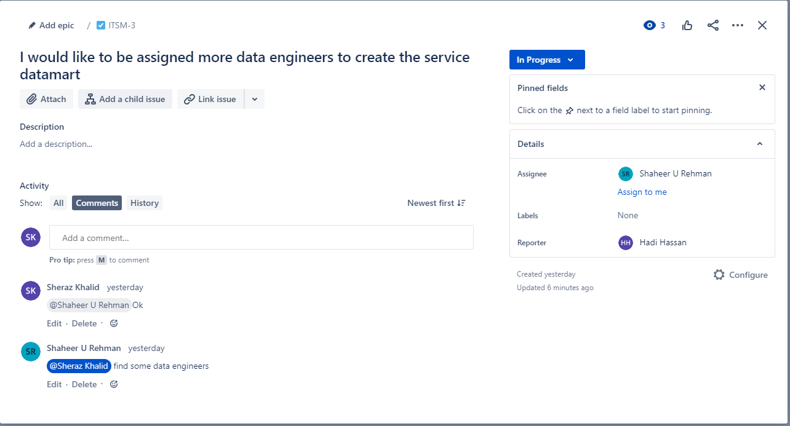

### Issue 3: Our team needs to buy the new license for Talend data service

Task: Our team needs to buy the new license for Talend data service

Assignee: Shaheer-Ur-Rehman

Reporter: Hadi Hassan

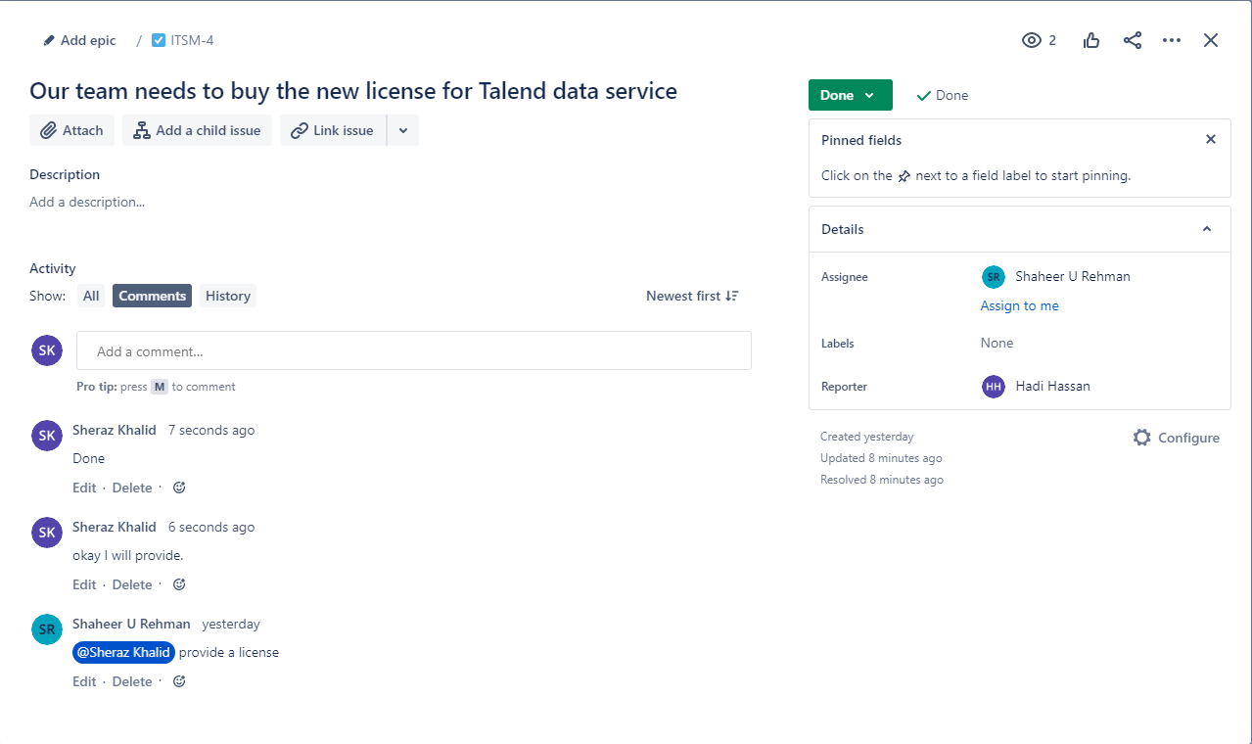

In the above screenshots you see three issue is created and assign to different team members.

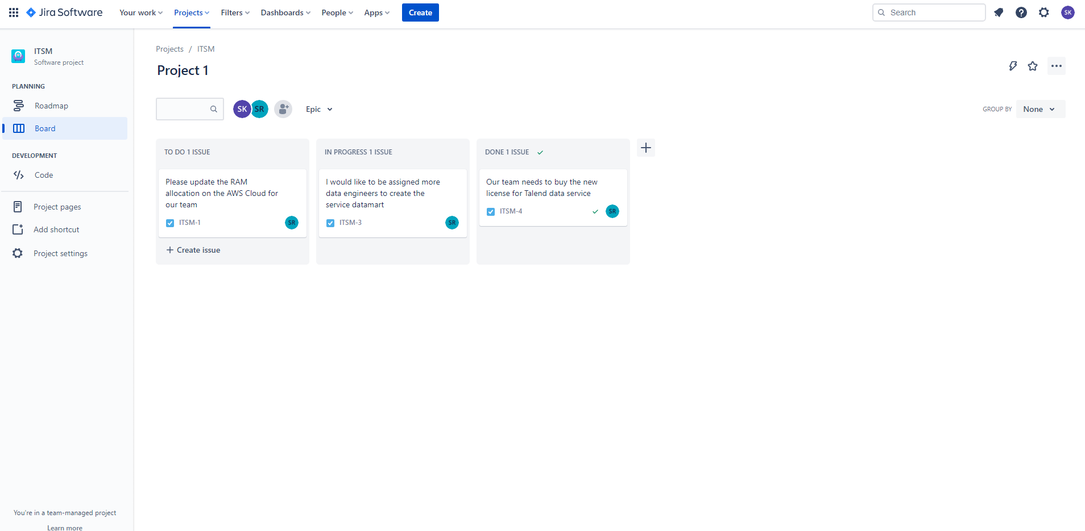

## ITSM sample space

In this project we used the Jira service management to put request to provide services according to issue in this show I demonstrate request 2 how to work.

### Request 1: Update Windows 10 to Windows 11

Project: ITSM sample space

Issue Type: [System] Service Request

Summary: Update Windows 10 to Windows 11

Assignee: Hadi Hassan

Reporter: Sheheer Rehman

Sheheer Rehman raised request.

### Request 2: Need username and Password customer cloud computer to install antivirus.

Project: ITSM sample space

Issue Type: [System] Service Request

Summary: Need username and Password customer cloud computer to install antivirus.

Assignee: Hadi Hassan

Reporter: Sheraz Khalid

Sheraz Khalid raised request.

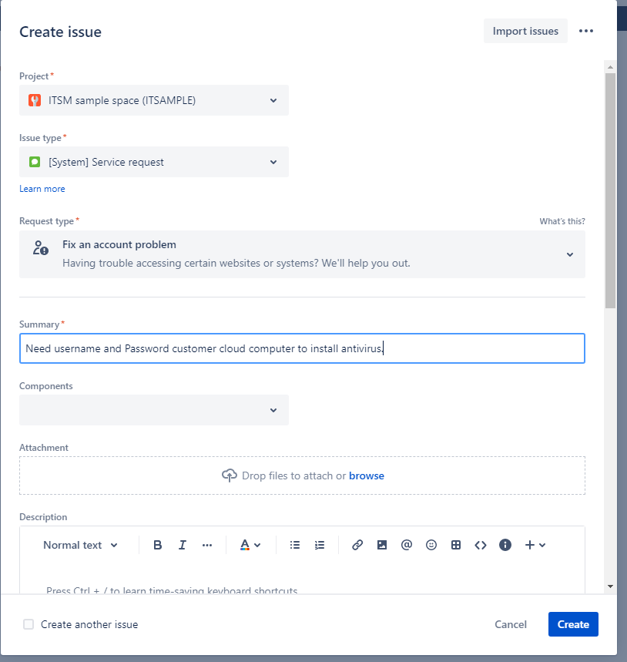

First we create issue by giving detail of request in this we provide project name Issue type and summary of issue. After created issue its goes to waiting support tab.

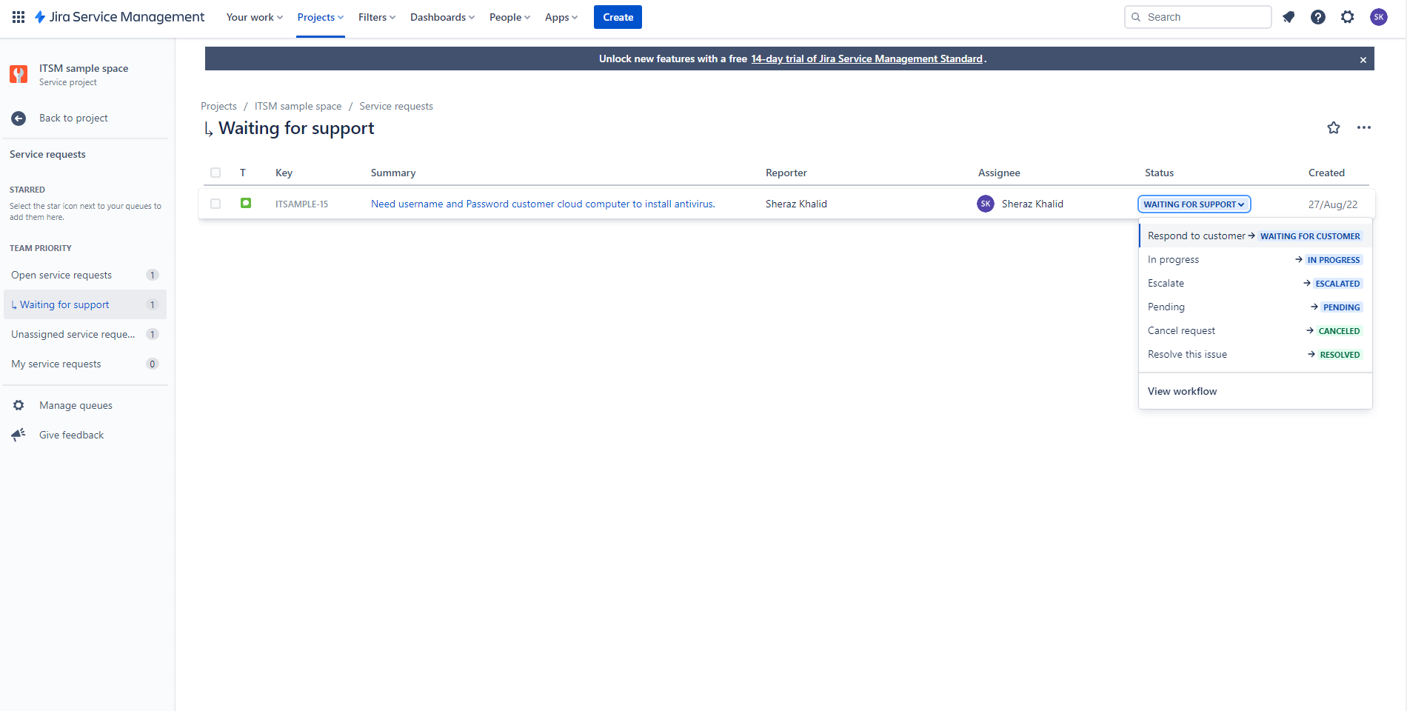

In “waiting for Support” tab it shows the status of issue in which state currently it is in waiting for support. After click on “In Progress” give the comment it shows someone working on it

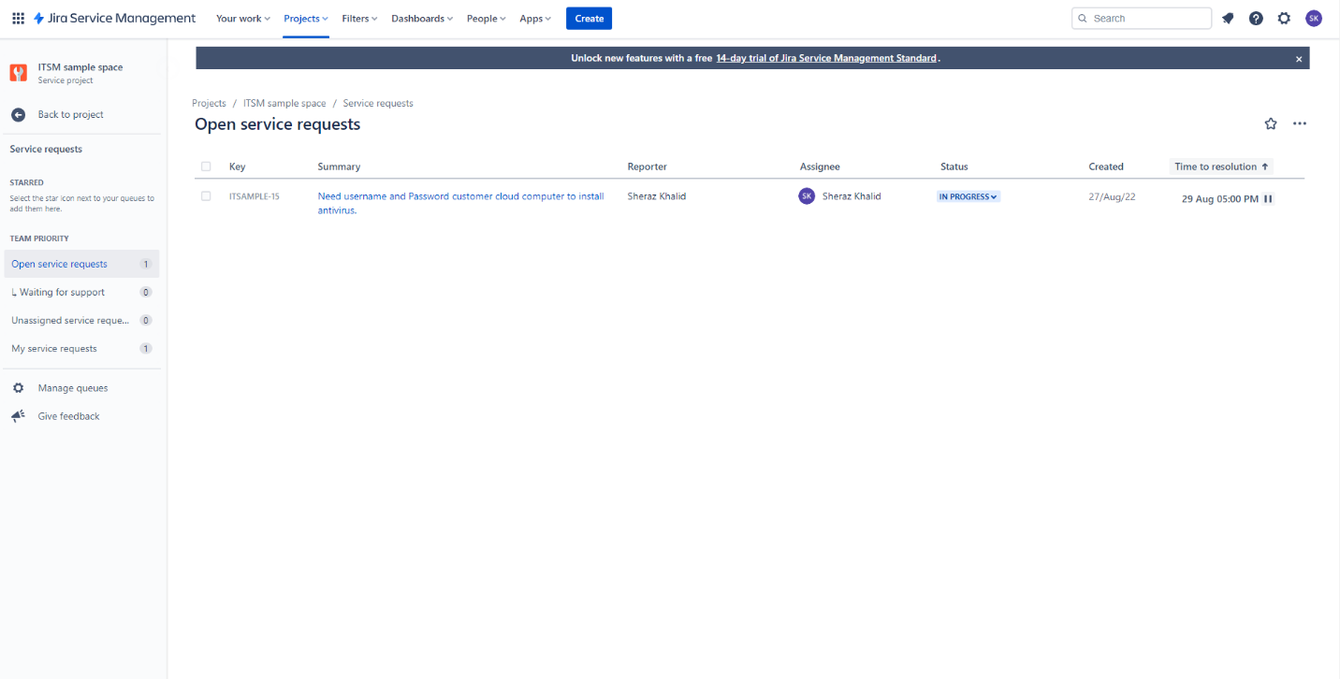

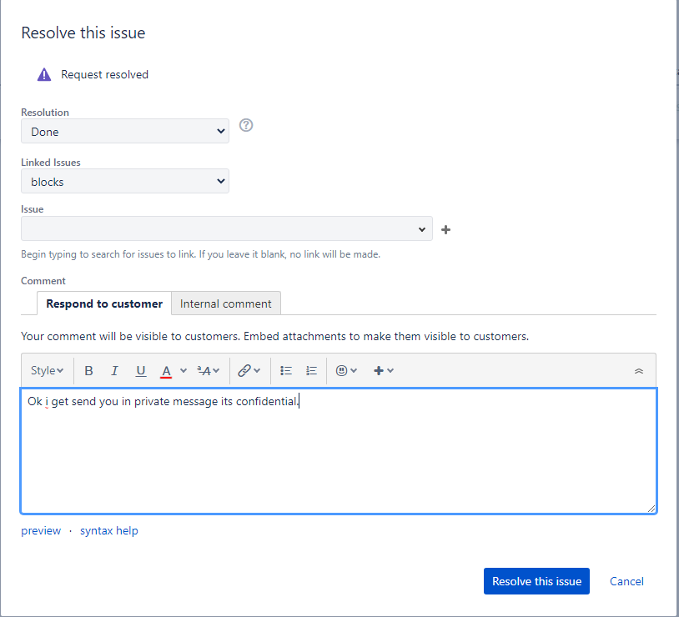

After Providing Services we resolve the issue and it disappear from “Waiting from Support”